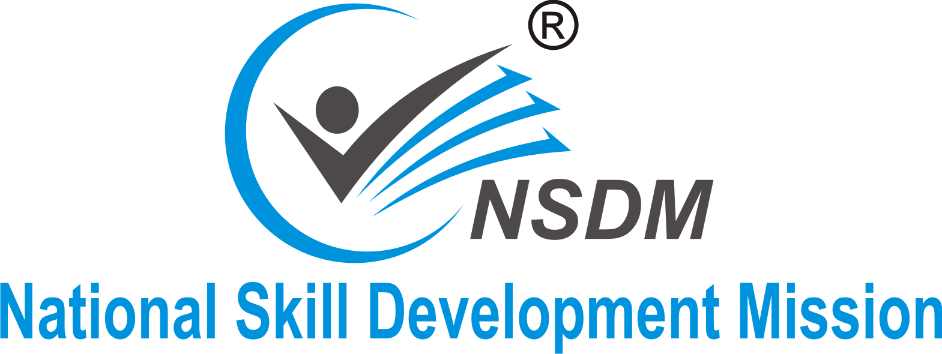

An ISO 9001:2015 Certified Organization
^{Managed & Run by Pathfuture}
An Autonomous Institution Govt. Registration. No- IV 190307714
- Registered Under Trust Act 1882, Govt. of India
- Registered Under Central Vigilance Commission
- Registered Under Trademark Act of India
- Under Copyright Act (MHRD)
- ISO 9001:2015 Certified

:: Proposal For Establishing Authorized Study Centre::
Infrastructure

- Centrally Located Center Preferably in Commercial Location.
- Minimum 500 sq. ft. Owned / Rented / Lease Space.
- One Dedicated Lab Provided for at least 5 (Five) pcs. having the arrangements for sitting
- 10 (Ten) Students at a Time. (Machine: Student = 1: 2). One Notice Board inside the Lab.
- One Dedicated Theory Classroom with Desk & Table for Minimum 10 (Ten) Students at a Time.
- One White Board and one Table Instructor inside the Classroom.
- Dedicated counseling area separate from the theory classroom.
- In addition to the above the following facilities should be available.
- One Toilet
- Arrangement for fresh Drinking Water.
- A waiting area for Students and Enquiry.
- One Telephone connection and Internet connection.
- One Printer.
- One Inverter or Generator set.

Personel

- Must have any knowledge & Experience in this field.
- Must have good reputation in the market.
- Must be a graduate with good communication skill & pleasing personality.
- Must have well profile and having capacity for social work.
- Sound financial position.
- One approved and trained faculty member being offered by the centre.
- One academic counselor.
- One Lab Assistant.
Investment & Involvement
Investment & Involvement Investment Inv
- Adequate Funds to setup the infrastructure and efficiently manage the centre.
- Centre Administration.
- Overall Quality Management.
- Local Promotions
- Authorization Fees
Authorization Fees

Pay Sum of Rupees @ Rs 10,000/- (Ten Thousands only) to @Rs. 25000/- (Twenty Five Thousands only) as a processing fee through NEFT (National Electronic Fund Transfer) or Bank Draft in favor of “ Pathfuture” Payable at Bally. The affiliation fee is non refundable.

BANK ACCOUNT DETAILS

Name of the Bank – United Bank of India Branch - Dalhousie square
A/C Holder Name – Pathfuture IFS Code - PUNB0058920
A/C No. - 0589010134927 BRANCH CODE- 196
.
Documentation Needed

The Following Documentation Required for Agreement:-
- 2 Copies Passport Size Photograph.
- Photo Copy of Voter ID/Adhaar Card.
- Photo Copy of Pan Card.
- Trade License / Registration Certificate.
- Partnership Deed (If Applicable).
- No Objection Letter from property owner.
- Photography of Centre
(Theory Room, Practical Room, Office Room, Front Side etc.)

Goods Provided by NSDM against Franchisee Fee
PARTICULARS | PIECES | PARTICULARS | PIECES
Front Flex (5’ X 2’ without frame ) | 1 pc | Sample Student I card/Admit Card | 1pc.
Flex Front Flex (4’ X 2’ without frame ) | 1 pc | Sample Student Kit | 1 pc
Colour Poster (20” X 15”) | 1 pc. | Sample Student Certificate | 1 pc
In House Poster (12” X 18”) | 1 pc. | Sample Student Mark sheet | 1 pc
Operation Manual Book | 1 pc | Authorization Letter/ Certificate | yes
Black & White Handbill | 500 pc | Centre Registration & Authorization Name on Website | Yes
Black & White Poster (20” X 15”) | 1 pc | Online Student Registration Display | yes
Prospectus | 1 pc | Study Centre Login ID & Password on Website | yes

Terms & Condition with Authorization for NSDM

- Renewal of authorization for the next year will be made FREE on the account of admission of at least 50(Fifty) students (NSDM courses) in a Financial year. Otherwise, renewal of authorization fee worth Rs. 1000/- (One Thousands only) will be chargeable.
- Registration form of each and every student must reach Head office/Regional office within maximum 30 days of admission of the student.
- Centre director has to pay student Registration Fee (see the registration fee structure) to the Head office.
- Submit of admission form without Registration Fee not to be considered under any circumstance and any kind of Issue duplicate copy of any kinds of kits provided by our organization without the consent of Head office is strictly prohibited.
- The organization reserves its right to make any addition or alternation in its Terms & Condition / Renewal fee / Registration fee without any prior notice.
- Any type of fee will not be refundable in any circumstances.
- No Liabilities Regarding the Staff Salaries, Taxes, Computers, Computer’s Software &Your Official Problems Will Be Borne by H.O. of NSDM Dalhousie.

Expectation from the Affiliated Study Centre

- The Study Centre should be able to have a Centre at a Prime Location of the City/Town. The Centre would have separate Class Rooms, Computer Lab and Reception / Office Room. The Centre would have Proper Ventilation and Proper Lighting. Study Centre should have generally clean surroundings.

- The NSDM study centre shall abide by the agreement and conditions followed by all NSDM centers.

- The NSDM study centre shall have to conduct courses as per the rules & syllabi laid down by NSDM.

- The NSDM study centre shall deposit an advance non refundable affiliation fee.

If you are interested
to work with us then Please
Submit Franchisee Application Form

For More Information, please Contact
9804927878/ 8013 000 780
Head Office:- 15 A, HARE STREET, DALHOUSIE, KOLKATA- 700001, WEST BENGAL, INDIA
Website:- www.nsdm.in ; Email:- info.nsdm@gmail.com

